NOMINATION OF BILLY RAY DUNCAN FOR
WILLIAM HARLEY GANDY DISTINGUISHED SERVICE AWARD

The undersigned are delighted to nominate Billy Ray Duncan as this year’s recipient of the Willaim Harley Gandy Distinguished Service Award presented by the Montgomery County Historical Commission. Mr. Duncan is the president of the Montgomery Historical Society.

The William Harley Gandy Distinguished Service Award is presented at the discretion of the Montgomery County Historical Commission to those special individuals, corporations or organizations who have exhibited distinguished leadership, initiative, and dedication to the preservation of the history of Montgomery County. The winner of the award must have shown significant accomplishments in the field of historical preservation and research. Such achievements must be notable and have made an important contribution to the preservation and/or advancement of the history of Montgomery County.

Having been raised in the historic Montgomery community, Billy Ray Duncan is a 1960 graduate of Montgomery High School. He grew up on his family’s farm northeast of town, located on old Bethel Road (now FM 1097). There he and his siblings were engaged in many common farm chores. He milked 60 cows at the dairy barn twice a day. His love for the town of Montgomery and its remarkable history therefore started at an early age.

After getting married and starting his family, Billy Ray continued his love for history in a variety of outlets: two involved collecting classic cars and searching with metal detectors for historic artifacts, many times with his brother Donald. His most precious find was a Republic of Texas naval uniform button that he found in 1976. In the 1990s, he and his brother Donald found 3 metal livery stable tokens on property located on the west side of Liberty Street in downtown Montgomery. These finds stimulated his interest in the early history of the Republic of Texas and of his hometown, which served as the county seat of Mongomery County from 1837 to 1889. Through his personal research on the early history of the town of Montgomery and of the Republic of Texas, he rapidly became one of the most knowledgeable historians of early Montgomery County. He is the local scholar to whom people turn when they want to know more about the area’s history. If he doesn’t know the answer, he persistently pursues research to find the answer.

In addition to being a resource for local history, Billy Ray Duncan has on many occasions been asked to assist with historical research on sites and persons outside of Montgomery County. He happily performs exhaustive research that connects Texas sites and personalities to other Texas counties and, in some instances, to other states.

Among his many research pursuits is that of the life of General Sam Houston, the Republic of Texas’s first president who made frequent stops in the town of Montgomery before his death in 1863. Billy Ray’s study of the man has inspired him to collect period clothing similar to that of the Texas leader, and he has re-enacted the role of Sam Houston on numerous occasions by delivering the general’s speeches. Billy Ray is also an organizer and participant of the annual “Voices from the Past” cemetery tours each October and the “Christmas in Historical Montgomery” home tours each December, both of which are sponsored by the Society and supported by the Montgomery County History Taskforce.
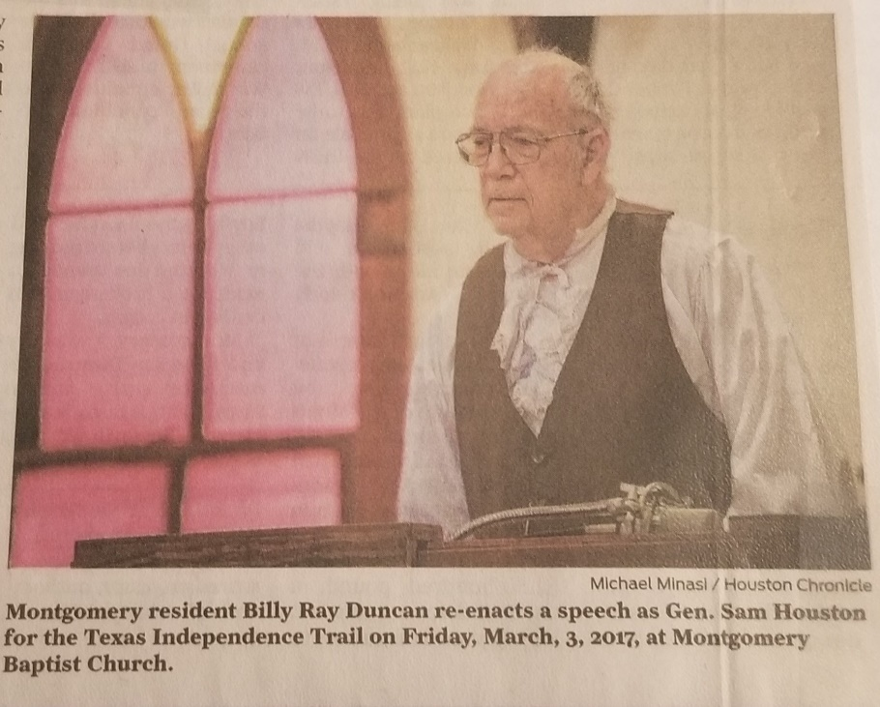

Finally, Billy Ray is the primary caretaker of seven historic buildings in Montgomery that are owned and maintained by the Montgomery Historical Society. Along with other devoted members of the Society, Billy Ray regularly inspects and arranges inspections of these old fragile structures to identify deterioration that requires immediate attention and repair. He also oversees the maintenance of the Old Methodist Cemetery on Pond Street. He arranges for contractors to perform the repair work and when possible, he seeks reimbursement grants from the Montgomery County Historical Commission. In addition, he often gives tours of these buildings.

Going forward, the dedicated work that members of the Montgomery Historical Society are performing, under the leadership of Billy Ray Duncan, will have a significant impact on the appreciation of our county’s precious history for generations to come. The historical information they are collecting and their faithful stewardship of the historic artifacts, buildings and sites in the City of Montgomery cannot be overestimated. Billy Ray Duncan and other members of the Society are indispensable to the heritage tourism programs that draw visitors to the City of Montgomery, that raise the awareness by the city’s residents to their city’s cultural heritage, and that improve the quality of life for its residents.
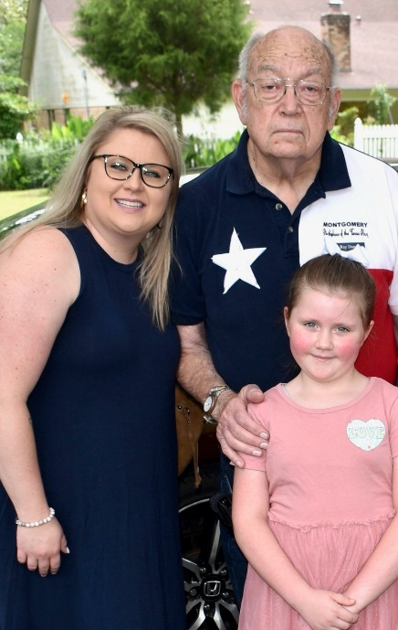
Billy Ray with granddaughter and
great granddaughter

For years Billy Ray has tirelessly but quietly devoted himself to the Montgomery Historical Society and to the citizens of the City of Montgomery. He has done so with humility and with no expectation to be publicly recognized for his numerous contributions. It is for those reasons referenced above that we enthusiastically nominate Billy Ray Duncan for the William Harley Gandy Distinguished Service Award. No one is more deserving of this special recognition.

Larry L. Foerster, Chairman, and Dr. Robin N. Montgomery, Member

Montgomery County Historical Commission

June 1, 2024

