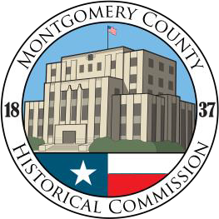

January 2021

MONTGOMERY COUNTY HISTORICAL COMMISSION MONTGOMERY COUNTY, TEXAS

**2020 ANNUAL REPORT TO MONTGOMERY COUNTY COMMISSIONER’S COURT**

**WHAT IS THE MONTGOMERY COUNTY HISTORICAL COMMISSION?**

*The official state agency for historical preservation, the Texas Historical Commission (****THC****), was created originally in 1953 as the Texas State Historical Survey Committee by the Texas Legislature. It retained that title until the 63rd Legislature changed it to the Texas Historical Commission.*

*The Montgomery County Historical Commission (****CHC****) is a duly constituted organization of Montgomery County government composed of citizen members who are appointed by the Commissioners Court and serve for two-year terms. The Commission reports to the County Judge and the Commissioners Court. It also reports to the Texas Historical Commission. As a county department, our Commission also publishes notice of our public meetings as required by the Texas Open Meetings Act.*

*The County Historical Commission has followed the Texas Historical Commission’s on-going purpose of surveying, recording and promoting the appreciation of local history as well as marking those historic sites and structures deemed worthy of preservation for either historical or architectural reasons.*

*The Commission works in various fields, including archeology, architecture, history, economic development and heritage tourism for the benefit of present and future generations. The agency helps identify and preserve historic sites and helps to preserve the heritage of Montgomery County. Historic preservation is a vital part of a promising future within our community.*

**MISSION**

* *To discover, and as appropriate, circulate information pertinent to the historical identity of Montgomery County, Texas, such as the placement of historical markers.*
* *To cooperate with other persons, groups, organizations and agencies in preserving the history and heritage of Texas.*

**RECAP OF COUNTY HISTORICAL COMMISSION (CHC) ACTIVITIES IN 2020**

1. COVID-19 CHALLENGES: As would be expected, the corona virus (COVID-19) pandemic this past year has affected some of our County Historical Commission’s programs in 2020. Nevertheless, our members have continued to pursue and complete several projects consistent with our mission.
2. MEMBERSHIP: The Commissioner’s Court recently reappointed 29 members to the County Historical Commission (CHC) for the 2021-2022 term, composed of a variety of individuals who bring special expertise, skills and background to the County Historical Commission. This includes two new member appointments made in 2020.

Former Historical Commission chairperson **Gertie Spencer** and Magnolia historian **Celeste Graves,** for decades two of our most beloved Commission members, have recently become honorary *Emeritus Members*. They remain engaged in our projects as best they can, since their knowledge of our County’s history is priceless.

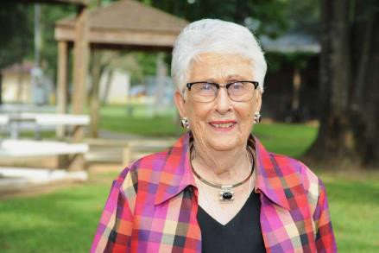

*Gertie Spencer Celeste Graves*

1. MEMBERSHIP MEETINGS: The Commission schedules six regular meetings every other month during the year beginning in January. (The Texas Historical Commission asks that each county historical commission meet at least four times each year.) Meetings have been held for several years at the Greater Conroe-Lake Conroe Chamber. However, the COVID-19 pandemic has affected our in-person meetings. Beginning in March, we have conducted our meetings virtually, using Zoom videoconferencing and teleconferencing, hosted by member **Annette Kerr**. Our meeting attendance has been excellent under these circumstances.
2. COUNTY HISTORICAL COMMISSION WEBSITE: The ***Website Committee*** under the leadership of **David Frame** continues to add content to the Commission website: [www.montgomerycountyhistoricalcommission.com](http://www.montgomerycountyhistoricalcommission.com/). It is designed to serve as an internet archive for reports on Historical Commission activities, provide State and County references, historical articles and photos, slideshows and videos of Montgomery County’s

people and places, and to provide an interactive map of historical sites throughout the County. The map displays each historic location with an individual “pin” that links to a historic narrative providing the reader with detailed information about each historical site, building and cemetery. There are presently 111 pins: 62 for State Markers and 51 for cemeteries. The website committee is collecting GPS location data and content for an additional 111 sites.

The CHC website is also available as a clearinghouse for many other county and state historical societies and museums. It also offers a calendar of events for county-wide historical organizations, county residents and tourists. Ongoing improvements to our Commission website include more flexibility for daily updates; a more attractive home page; mobile friendly upgrades for smart phones; links to Facebook, Instagram, and other social media so that we can more effectively reach a larger audience. We are exploring the capability to support an online payment system for book sales and donations.

1. HISTORICAL RESOURCE SURVEY: The CHC has been interested in updating and digitalizing the CHC’s ***Historical Resource Survey*** to identify all historic sites and buildings in our county. The only such survey was conducted in 1980, is found in two large three-ring binders, and is out of date. The local congregations of the Church of Latter-Day Saints have volunteered to assist us with the update of the Survey. Beginning in November 2020, members met with **Chairman Larry Foerster** to develop a game- plan for updating the Survey beginning with structures in Conroe. The volunteers’ goal is to complete the survey of historical structures in Conroe before the end of 2021. Thereafter, the team will methodically move from city to city throughout Montgomery County to digitally catalog historical structures. This information can be used for our website’s map of historical sites, buildings and cemeteries throughout the County. This project will also help the Commission identify and protect old historical structures that may be planned for demolition or otherwise damaged.
2. HISTORICAL PRESERVATION: **Ron Saikowski** chairs our ***Endangered Building Committee*** which will continue to identify threatened old historic buildings that may be subject to demolition or need repair or be qualified for designation with a historical marker. The Texas Historical Commission has urged county historical commissions to prioritize the preservation of historic buildings and other structures across the State that are threatened by new development. As these are identified, your CHC is constantly looking at ways to restore and repurpose these structures consistent with our mission statement.

Of immediate importance is the preservation of the ***one-lane old iron truss bridge*** spanning the San Jacinto River at FM 2854. County records show that this bridge was constructed by El Paso Iron and Bridge Company for the County in 1910 and served for many decades as the state highway 105 bridge from Conroe to Montgomery. Bonnie and Clyde were reported to have met his relatives under the bridge in the early 1930’s.

Regrettably, it was damaged by the San Jacinto River flood waters during Hurricane Harvey in 2017 and its condition is fragile. The Texas Highway Department and the Texas Historical Commission are urging local authorities to save and repurpose these historic structures. The CHC continues to encourage the preservation of the bridge.

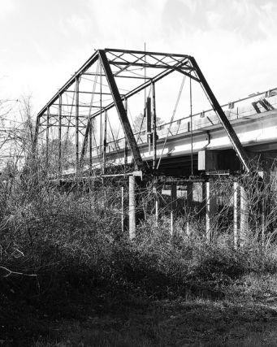

*San Jacinto River 1910 Truss Bridge*

The CHC is constantly exploring ways to save historic structures. Regrettably, we do not always succeed. In the spring of 2019, the County and the City of Conroe lost three very historic downtown structures to the wrecking ball: the 1911 Everett Hardware store, the 1911 First State Bank of Conroe and the first silent movie theatre in Conroe (circa 1916). Given the significant cost of saving these historic brick structures, the owner felt compelled to demolish them. However, there are plans to construct buildings on the site that will pay homage to the history of these buildings.

The good news is that in 2020 the City of Conroe hired **Frank Robinson** as the downtown manager to promote its plans to redevelop a large area on both sides of the Union Pacific railroad tracks. Frank brings a new energy to the City’s commitment to preserve and redevelop historic areas of the downtown area. He is working with urban designers on ways to incorporate the older buildings into new downtown businesses, applying upscale development concepts. Frank has also had several meetings with members of the Commission to incorporate our ideas into downtown plans. These discussions have included new uses for old structures and the creation of one or more historic residential districts off the downtown areas. Chairman **Larry Foerster** serves on the city’s Architectural Review Board as a resource for identifying and preserving the historical character of these important structures.

Among the recent downtown restorations are the former **Carter Drug Store Building** and the former **First National Bank Building.** The Carter Drug Store Building was constructed in 1913 as the H C Addison mercantile store before it became the Carter Drug Store in 1919. The First National Bank building is believed to be the oldest commercial building in the County, circa 1900. It now serves as the law offices of attorney Tay Bond who has made major restorations of the building. It is expected that

the owners of these buildings will be applying for county historical markers in 2021. We also want to add other county markers for historic structures in downtown Conroe and there is a growing interest among other owners in applying for these historical markers.

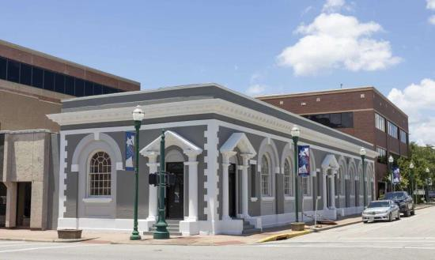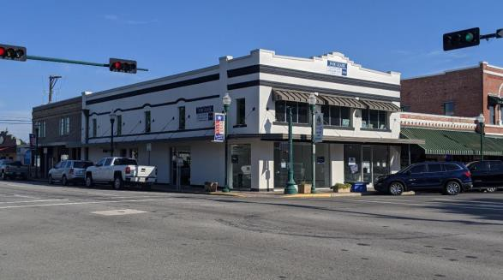

*First National Bank Building Addison – Carter Building*

Several other historic downtown buildings are being converted for a new brewery, winery tasting room, whiskey tasting room, and retail stores. The interior of the historic 1935 **Crighton Theatre** is also being remodeled and the theatre lobby is being expanded into adjacent space next door. There are plans to apply for a state historical marker for the Theatre in 2021.

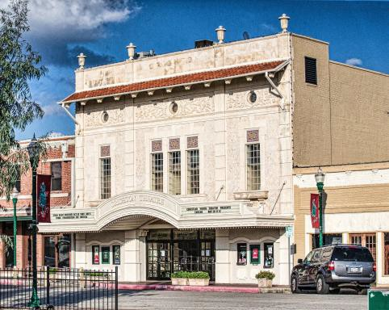

*Crighton Theatre*

The **Conroe Community Cemetery** has also been targeted by our Commission for preservation and recognition. This previously overgrown cemetery is the burial site of Sgt Luther James Dorsey of the 10th US Calvary, the only known Buffalo Soldier in Montogmery County. It is also the final resting place of other notable African Americans from our community. In 2020 our Commission donated the necessary funds to install a fence along two sides of the cemetery to protect the tombstones from vandals. Several members have participated in the ongoing restoration of this cemetery and attended the cemetery sign dedication ceremony held in October.

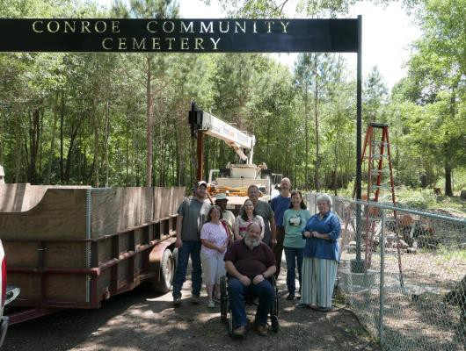 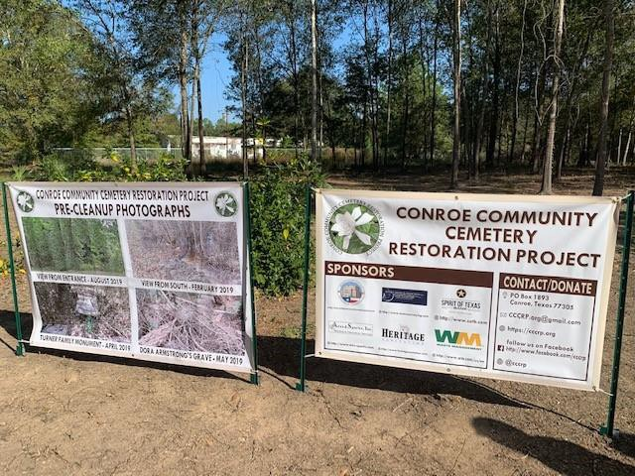

*Conroe Community Cemetery entrance and signage*

CHC members **Elijah Easily, Ron Saikowski, Ryan Londeen, Maria Banos Jordan, Jean Mann and Sharon Russell** have been engaged in plans for the restoration of the ***Sweet Rest Cemetery in Tamina*,** which is one of the earliest African American cemeteries in the County. It is presently covered in standing water. **Commission James Metts** has also assisted with the flood mitigation plans for this historic cemetery. In addition, Marker Committee chairperson, **Sharon Russell** has applied to the THC for a state *Undertold Historical Marker* for the Tamina Freedman Community.

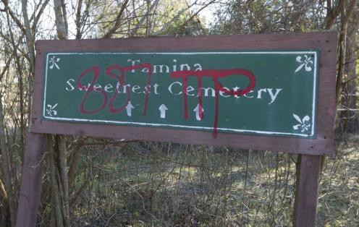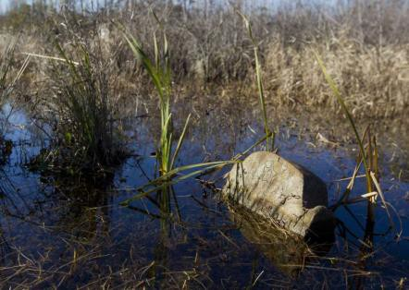

*Tamina Sweet Rest Cemetery*

In December, **Larry Foerster** met with individuals interested in preserving the ***William F. Malone Family Cemetery*** located in a gated residential subdivision west of Willis. William F. Malone served in the Confederate Army during the Civil War and in 1891-1892 was the elected state representative from Montgomery County. The cemetery was only discovered in 2015 and is on an overgrown lot owned by the subdivision owner. A Conroe boy scout has offered to clear and restore the cemetery for his Eagle Scout project.

1. YOUTH ADVISORY BOARD. This is the eighth year for our ***CHC Youth Advisory Board*.** It is composed of high school students selected by their teachers and administrators from high schools throughout Montgomery County. This Youth Advisory

Board*,* or *“YAB”* as we affectionately call it, provides suggestions to the Historical Commission for the promotion of historical activities that would engage students’ interest in our local and state history and recruit student volunteers to assist the CHC and other historical organizations in the preservation and promotion of historic buildings, sites and cemeteries throughout Montgomery County. This student organization—the first of its kind in the State of Texas—meets monthly during the school year.

YAB students were able to assist us with our History Road Rally in Conroe in January. Unfortunately, the COVID pandemic stopped the YAB program in March and currently we have not reactivated the program until safety concerns are further reduced. Hopefully, we will be able to engage these young people in 2021. In addition, using money from book sales and donations to the CHC, a $1000 scholarship was awarded to **Kiley Cheatam**, a graduating YAB student from Willis High School, for her enthusiastic support of our Commission’s projects.

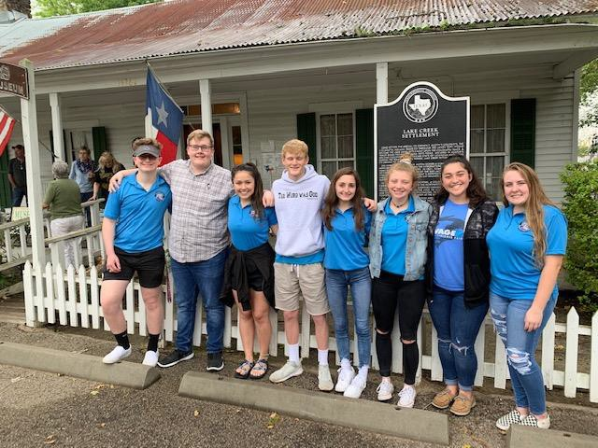

*YAB students on Bus Tour Kiley Cheatam (r) helping at History Road Rally*

1. HISTORIC PRESERVATION GRANTS: With the generous financial support of the Commissioners Court, CHC continues to offer grants to 501c(3) non-profit historical organizations around the County as reimbursement for rehabilitation of old historic structures. Working closely with County Auditor and County Judge’s staff, the CHC ***Grants Committee*** (composed of **Gertie Spencer** and **Anna Shepeard**) have developed guidelines and procedures for the CHC and Commissioner’s Court approval of such grants.

The largest grants in 2020 were to the **Conroe Community Cemetery Restoration Project** for a boundary survey of the cemetery and funding a chain-link fence along two sides of the cemetery. These funds were necessary to protect the historic cemetery tombstones and as part of plans to apply for a state historical cemetery marker. Grant funds were also provided to the **Magnolia Historical Society** for sealing the roof of the 1902 Magnolia Depot Museum; the **Montgomery Historical Society** for its rehabilitation of the historic Nat Hart Davis Home Museum; and the **Heritage Museum of Montgomery County** for repairs to the museum and partial funding of its historical archives room in the museum.

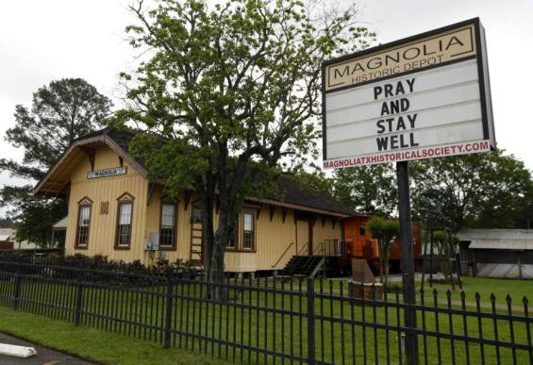 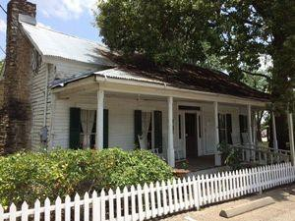

*Magnolia Depot Museum Nat Hart DavisHome Museum*

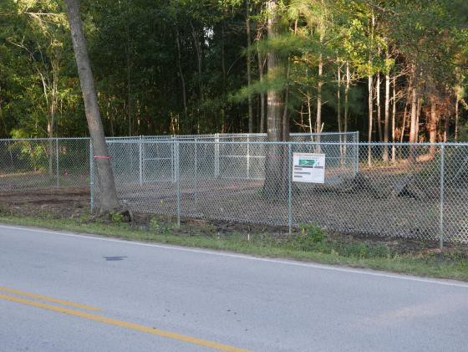

*New fence at Conroe Community Cemetery*

1. STATE HISTORICAL MARKERS: A state historical marker for the ***Elizabeth Shaw Cartwright Family Cemetery*** near Montgomery has been produced, and we are planning a major dedication ceremony with the Cartwright family early in 2021. There are plans to pursue designation of state historical markers for the burial site of Isaac Conroe in Houston; the Crighton Theatre in Conroe; the abandoned towns of Danville and Fostoria; the communities of Grangerland, Splendora, and New Caney; and several historic post- Civil War cemeteries: the Tamina Sweet Rest Cemetery and the Conroe Community Cemetery.
2. COUNTY HISTORICAL MARKERS: A new county historical marker was dedicated in October at the 1919 ***Willis A. Dean house in Magnolia***. The research for the marker application was done primarily by our 100-year-old Commission member and Magnolia historian, **Celeste Graves.** The ceremony was attended by **State Senator Brandon Creighton, Commissioner Charlie Riley**, former **constable David Hill**, and several Magnolia city officials.

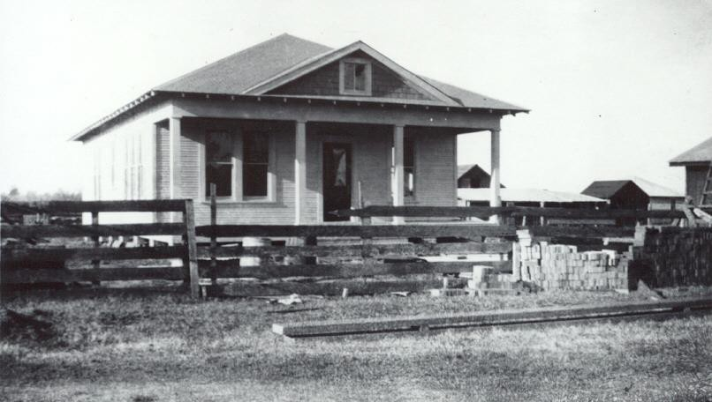 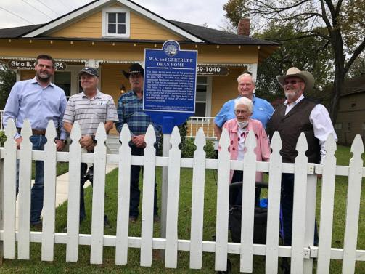

*W. A Dean house in 1919 and county officials at dedication ceremony*

In November, a second county historical marker was dedicated at the ***Addison- Gandy House in Montgomery*.** This 1892 structure is one of many historical homes in this old town which was platted in July 1837. The old home served as a boarding house in the early 1900’s by Mrs. Addison, the daughter of famous local judge Nat Hart Davis who lived next door. Participating in the dedication ceremony were the county **Commissioner-elect Robert Walker** and the Montgomery **city mayor Sara Countryman**, along with Gandy family descendants and members of the Montgomery Historical Society that now owns the house.

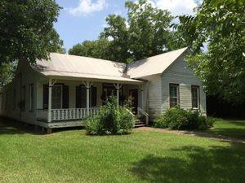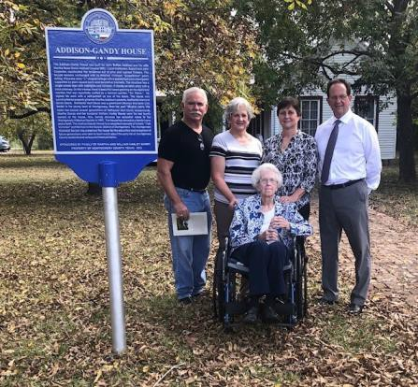

*Addison-Gandy family at marker dedication*

***Marker Committee and Cemetery Committee*** chairperson **Sharon Russell** is currently working on county historical markers for the Turner Thomas Cemetery near Magnolia and the Piney Grove Baptist Church and Cemetery. She and other members of our Commission have been asked to assist with marker applications for the Henry Dean General Store in Magnolia, the Decker Prairie School, Magnolia High School, and Arnold-Dean Cemetery near Magnolia.

1. COUNTY HISTORICAL TIMELINE: With the support of former County Judge Sadler and the County Commissioners, CHC Chairman **Larry Foerster** completed his extensive ***Montgomery County, Texas Historical Timeline*** which was published in January 2014*.*

This 239-page bound book—complete with historic photos, old drawings and maps— offers a detailed chronology of notable historic events in Montgomery County from the time of the Native Americans to the present. The book was provided for free to all county libraries and has been made available for sale to the public as a fundraising project for the CHC. Over $22,000 has been raised from 2014 through 2020 from the sales of the book to support future preservation projects of the Historical Commission. With additional historical information and photographs provided by county families since the book was published in 2014, Larry Foerster is currently working on a revised and even more detailed second edition of the book which is scheduled for publication by the end of 2021.

1. CONROE PICTORAL HISTORY BOOK. Throughout 2020, several members of the CHC have been collaborating with *Courier* newspaper writer **Sondra Hernandez** on a pictorial history book of the City of Conroe. CHC members **Dr. Robin Montgomery, Joy Montgomery and Larry Foerster** have assisted Ms. Hernandez on this Arcadia Publishing Company book, which is now available for sale.
2. HISTORY ROAD RALLY: The Commission sponsored its 7th annual ***History Road Rally*** in Conroe in January. Promoted as “Driving in the *Past* Lane,” each year the event features the local history of a different area of Montgomery County. This is a fun family- friendly event. Participating teams represented Texas communities in and beyond Montgomery County. The teams enjoyed following clues and finding their answers to county and state historical events, sites and individuals as they drove their vehicles around Conroe for two hours. The teams were delighted to meet former County sheriffs **Tommy Gage** and **Joe Corley** who served as docents in the old fifth-floor courthouse jail. Each participant received a souvenir “History Road Warrior” button. The teams returned for free pizza and drinks while their answer sheets were judged. The three winning teams received trophies and $25 gift cards courtesy of our sponsor: Gullo Ford, Gullo Toyota and Gullo Mazda automobile dealerships of Conroe.

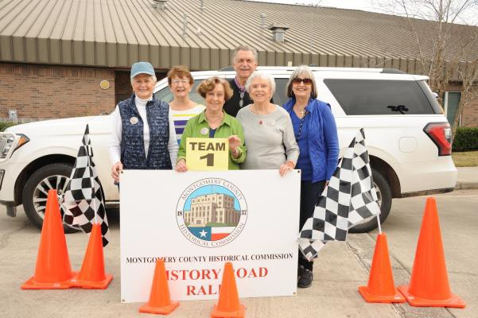

*Annual participating road rally team Annual participant’s history rally buttons*

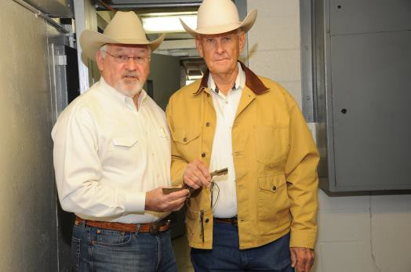 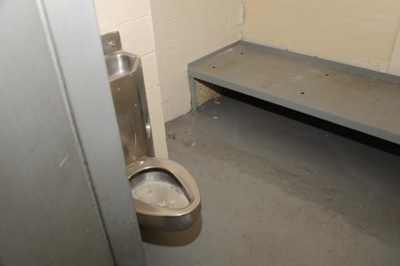

*Former Sheriffs Gage and Corley at old courthouse jail*

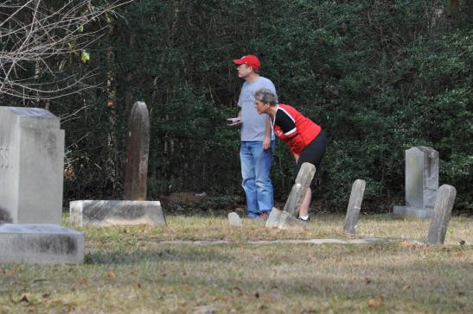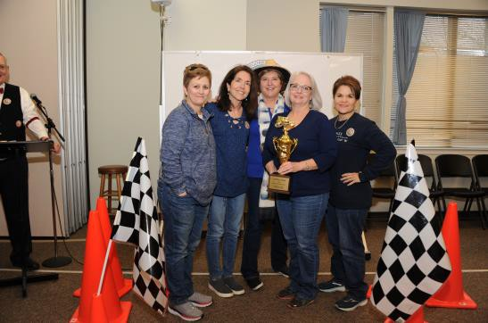

*Searching for tombstone clues County clerks’ team celebrating victory*

1. WILLIAM HARLEY GANDY DISTINQUISHED SERVICE AWARD. This past November, the CHC presented both **Jon Edens** and **John Meredith** with its fourth ***William Harley Gandy Distinguished Service Award***. Mr. Edens and Mr. Meredith have lead volunteers in identifying, researching and restoring the historic African American Conroe Community Cemetery. Their inspirational efforts have generated a remarkable community-wide effort to restore the cemetery and to honor those persons buried there, one of which is 10th US Calvary Sgt Luther James Dorsey, the only Buffalo Soldier known to be buried in our County.

This award is presented at the discretion of the Montgomery County Historical Commission to individuals, corporations or organizations who exhibit distinguished leadership, initiative and dedication to the preservation of the history of Montgomery County. The winner of the award must have shown significant accomplishment in the field of historical preservation and research. Such achievements must be notable and have made an important contribution to the preservation and/or advancement of the history of Montgomery County. The award is named in honor of **William Harley Gandy**, the first chairman of the Montgomery County Historical Commission, a distinguished history teacher, and the author of the definitive 1952 treatise on the history of Montgomery County.

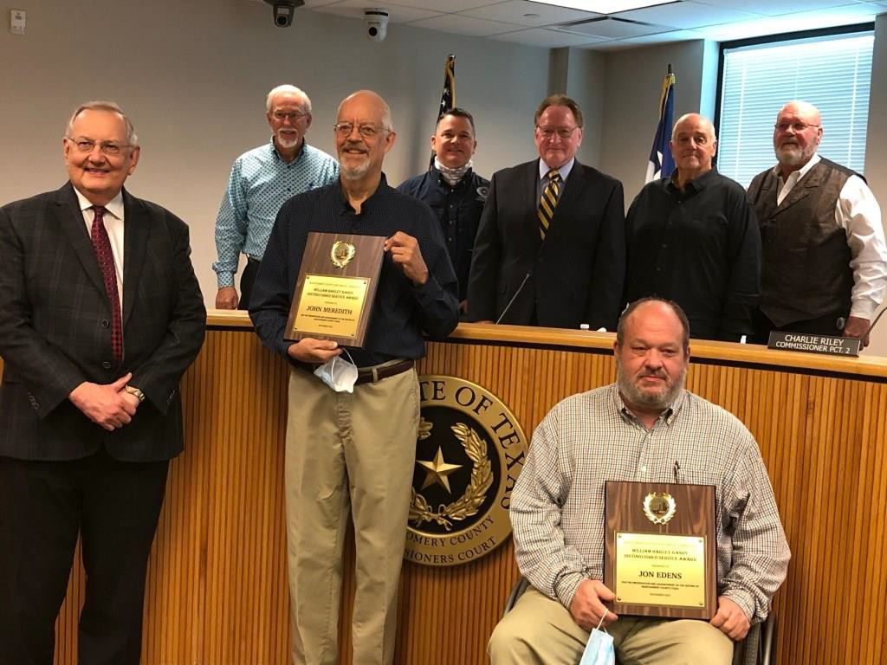

*John Meredith and Jon Edens accepting their awards at County Commissioner’s Court*

1. REVISED COMMISSION BYLAWS: A ***Bylaws Committee*** chaired by member **JoDell Whitehead** has reviewed the County Historical Commission’s Bylaws which were last revised in 2012. The committee submitted its report to the CHC at November meeting and final revisions were approved at that time which includes reorganizing some standing committees. The revised Bylaws have been sent to the County Attorney’s office for review before they are approved by the Commissioner’s Court.
2. REAL PLACES CONFERENCE: CHC Chairman **Larry Foerster** and member **Joy Montgomery** attended the Texas Historical Commission’s January ***2020 Real Places Conference*** in Austin. The conference provides fresh ideas and networking opportunities with other members of county historical commissions across Texas.

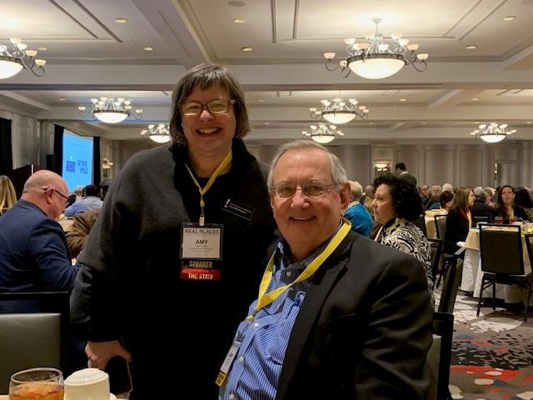

*Larry Foerster with THC staff member Amy Hammons*

1. PROMOTING MONTGOMERY COUNTY HISTORY: Over the past seven years, CHC members have collaborated with the Conroe *Courier* “*Trends”* editor **Sondra Hernandez** in producing a monthly Sunday article in the *Courier* featuring a historic Montgomery County event, building, person or residence. Commission members **Sharon Russell, Frank Johnson, Larry Foerster and Dr. Robin Montgomery** have contributed historical articles for the newspaper. With our input, historical features have also been produced in the *Community Impact* newspaper and the *Bluebonnet News* online newspaper. These articles are designed to generate interest and renew community pride in the history of Montgomery County.
2. INFORMATION CLEARINGHOUSE: The Historical Commission serves as a clearinghouse for the distribution of information and announcements among historical organizations and interested citizens in our County concerning upcoming events and projects of significant historical interest throughout Montgomery County and the State. Many of our members actively serve on the boards of other historical societies and museums in the County.
3. WALKING TOUR OF CONROE: Through a collaborative effort of the Conroe Convention and Visitors Bureau, the nonprofit Conroe Live, Inc., and Commission chairman **Larry Foerster**, a tri-fold self-guided historic walking tour brochure of Downtown Conroe has been published and is available to visitors in Conroe. The brochure features 14 historic buildings with photos provided by the Heritage Museum. It is complemented by a longer online narrative version available to visitors who go to the [www.visitconroe.org](http://www.visitconroe.org/) website.
4. ANNUAL TEXAS FLAG RAISING CEREMONY: Members of the County Historical Commission **Jim Walker** and **Larry Foerster** participated in the annual ***Texas Battle Flag Raising Ceremony*** at Conroe’s *Lone Star Monument and Texas Flag Park*. The annual ceremony was held on October 3 in connection with the anniversary of the commencement of the Texas War for Independence at the Battle of Gonzales. The ceremony honors the memory of the Texian soldiers who fought at the various battles of the Texas War for Independence in 1835-1836. The participants in 2020 included county and city leaders and former officers of the Friends of the Flag Foundation. The Texas Volunteers and the Rolling Thunder cannon also participated in this solemn event.

CHC member **Jim Walker** was recognized for his contribution to the planning and research for the *Texas Flag Park* and for faithfully serving as its Flag Master for almost ten years, routinely replacing tattered flags. State, County and Conroe city officials who also participated in the event were **Justice of the Peace Trey Spikes, State Representative Will Metcalf, Mayor Pro Tem Duke Coon** and **Councilman Ray McDonald**.

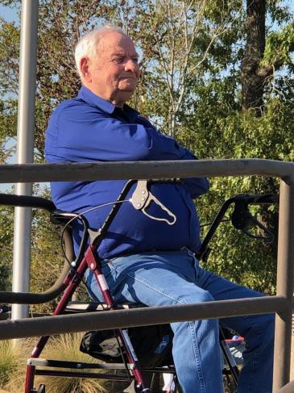 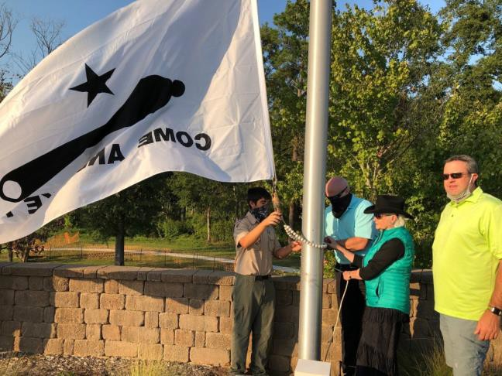

*Jim Walker Trey Spikes raising flag with his family*

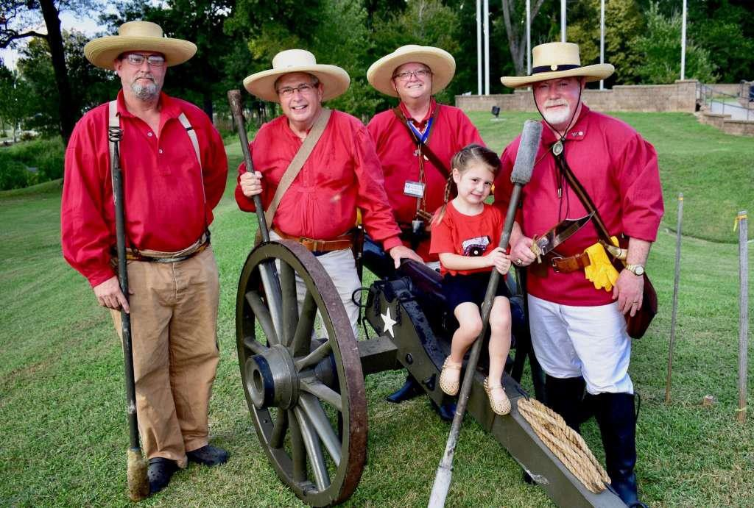

*“Rolling Thunder”Texian cannon crew*

1. VETERANS MEMORIAL PARK: Several CHC members have been involved in the promotion of the development of the ***Montgomery County Veterans Memorial Park*** in Conroe. When completed, this park will honor the memories of those men and women who have served Texas and our nation in wars beginning with the American Revolution and including the Texas War of Independence. The park is located across Alligator Creek from *The Lone Star Monument and Historical Flag Park*. In October, several of our CHC members attended the dedication ceremony of the *“Sgt Luther James Dorsey Memorial Bridge”* that spans Alligator Creek, connecting the two memorial parks. The bridge was named in honor of Sgt Luther James Dorsey, the only known Buffalo Soldier buried in Montgomery County.

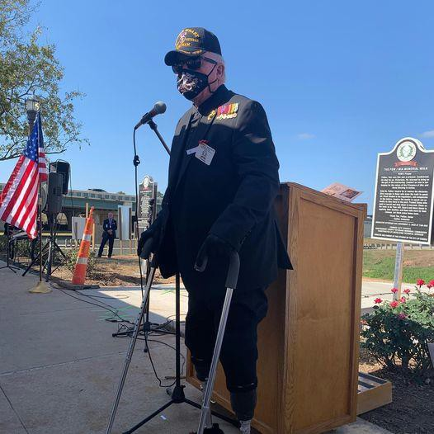 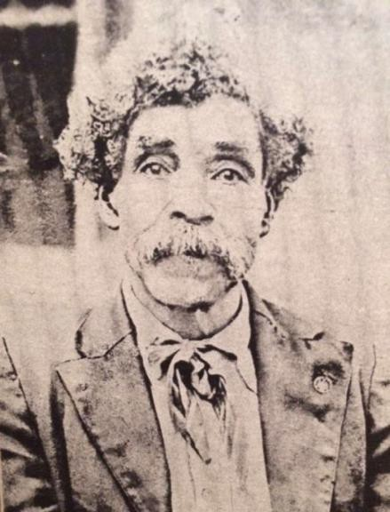

*Jimmie Edwards at bridge dedication Sgt. Luther J. Dorsey*

1. HISTORICAL PRESERVATION DISTRICTS: Members of the County Historical Commission are engaged with other organizations in generating community interest in the development of ***residential historical preservation districts*** around downtown Conroe and other older communities in Montgomery County. Collaboration with members of the Conroe City Council and its downtown manager **Frank Robinson** has generated interest in restoring historic portions of downtown Conroe from IH-45 to 10th Street on both the west and east side of the railroad tracks in downtown Conroe. The result is a new Conroe Development Plan that recognizes the historic “Old Town” section of Conroe from the railroad tracks east to 10th Street. A renewed interest in the business district of Conroe has led to investments in its historic buildings, with an interest in preserving and promoting these old structures. It is hoped that the area may someday be designated on the “National Register of Historic Places.”
2. SHARING COUNTY HISTORY WITH LOCAL ORGANIZATIONS: Several times during the year CHC Chairman **Larry Foerster** and other CHC members are invited to give presentations on Montgomery County history to numerous civic and youth organizations throughout the county with the goal of increasing local interest in our history. PowerPoint slide shows of historic photographs and maps are frequently used for these presentations. One such presentation was given virtually by Zoom by **Larry Foerster** to the George Mitchell Breakfast Club in The Woodlands in June.
3. TEXAS 2019 DISTINGUISHED SERVICE AWARD: Finally, we are very honored that your Montgomery County Historical Commission was recognized for the seventh

consecutive year by the Texas Historical Commission with the 2019 ***“Distinguished Service Award.”*** This is a coveted award from the Texas Historical Commission to a select few county historical commissions that “…demonstrate exceptional service and dedication to preserve the heritage of Texas.”



Respectfully submitted,

Larry L. Foerster, Chairman

Montgomery County Historical Commission